Creating a Github a/c

Step 1; goto and type github login

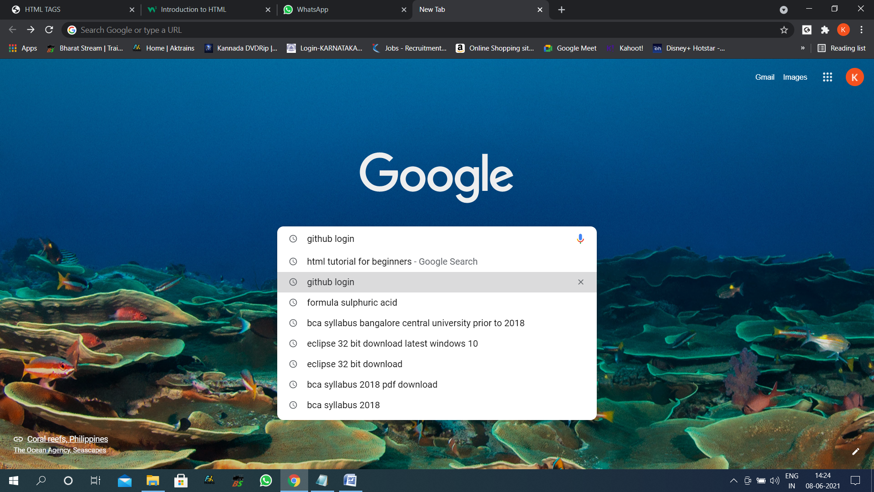

Step2; click on the link

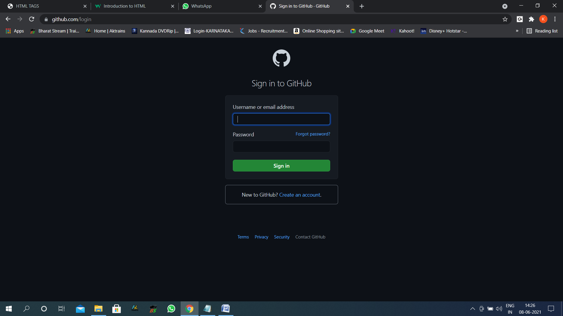

Step 3; then click on create account

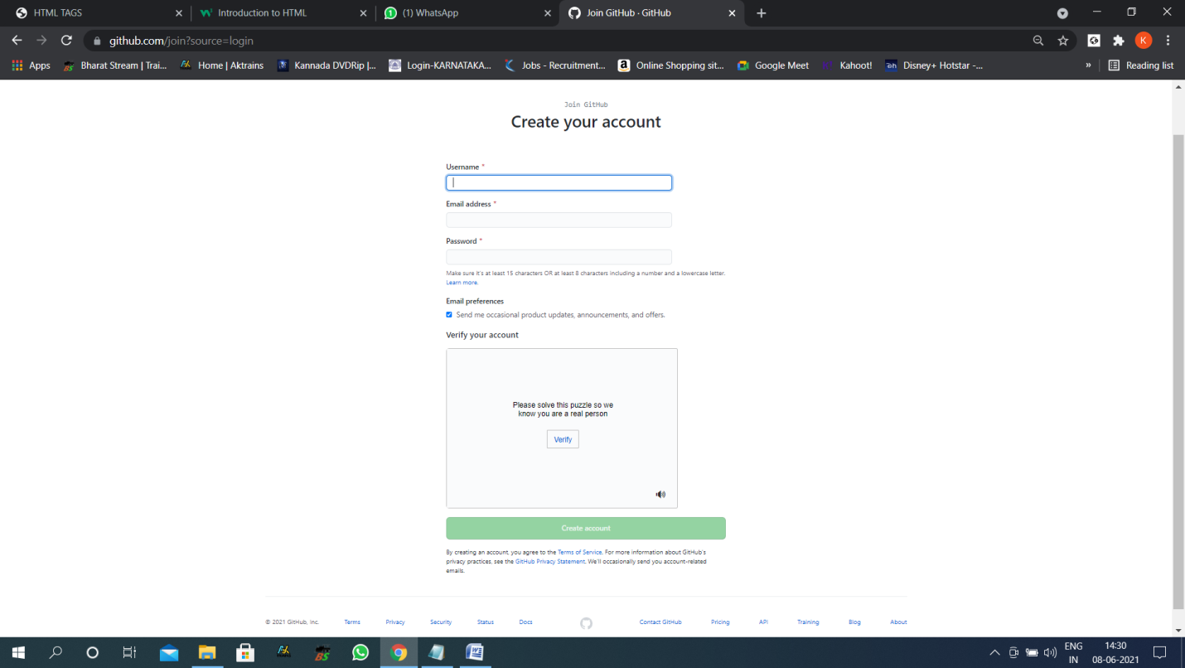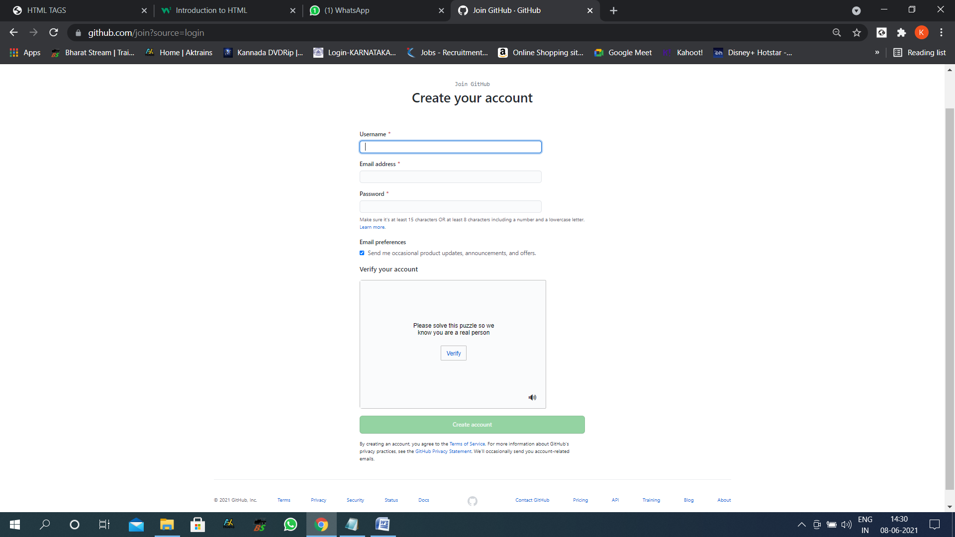

Step 4; enter the required field with the details like username email_id and enter the userdefined password for a/c

Step 5; verify the a/c using the link which is sent to user’s email

Step 6; login as a user then create a repository